Rules of the District Catchment Group Incorporated

THE SOCIETY

Name
  - The name of the society is The District Catchment Group (Society).

Registered Office
  - The registered office of the Society is and may be varied by the Committee Members by Majority vote.

Purposes of Society
  - The primary objective of the Society is to facilitate and promote "on farm good practice" in the area covered by the Reginal Plan and to promote sustainable land management principles.

  - The purposes of the Society include to:

    - Inform regional and district planning processes to work towards fair outcomes for all farmers in the Management Area;

    - Demonstrate and promote sound environmental stewardship by its Farming Members;

    - Provide environmental and production management tools to support good on-farm decisions;

    - Increase the uptake of good environmental farm management practices in the Management Area, including but not limited to assisting Farming Members with the development of Farm Environment Plans;

    - Ensure the ability of its Farming Members to farm sustainably, in a community which thrives and is not socially divided on the basis of nutrient allocation;

    - Collect and collate robust evidence on the environmental, social and economic impacts of farming to support the Society's purpose;

    - Grow understanding of the role of farming in managing local water quality;

    - Integrate environmental improvements and profitability--to bring farmers together to agree on good farming practice specific to their farms and management (business and environmental) goals;

    - Pursue and secure financial and in kind support for the Society to achieve its purpose; 3.2.10 Act as a collective voice for its Members when dealing with government and industry;
    - Identify the research and science needs of the Members to achieve the purpose of the Society;

    - Make regulations or bylaws to advance the attainment of any of the above objects; and

    - Do anything necessary or helpful to the above purposes.

  - Pecuniary gain is not a purpose of the Society and no Member of the Society shall derive any personal pecuniary and/or monetary gain from membership of the Society.
4.1 The Society has, to the extent permitted by law, full capacity to carry on or undertake any activity, including but not limited to:

Powers of Society
    - Employing people for achieving and assisting the purposes of the Society;

    - Exercising any power a trustee might exercise;

    - Investing in any investment that a trustee might invest in; and

    - Borrowing money and providing security;

in each case if authorised by the Society in accordance with these Rules.

DEFINITIONS

Definitions and Miscellaneous matters
  - In these Rules:

    - Act mans the Incorporated Societies Act 1908, all amendments and re-enactments thereof, including any subsequent or ancillary legislation intended to replace that Act and any subordinate legislation made thereunder.

    - Bylaws means the bylaws of the Society in place from time to time pursuant to clause 29.1.

    - Committee means the managing committee of the Society as referred to in Rule 6.

    - Committee Member means a member of the Committee appointed in accordance with these Rules.

    - Environmental Management Strategy means the Environmental Management Strategy developed by a Membership Group and approved by the Society

    - Farm Environment Plan means a farm environment plan for a Farming Member's farming operation that has been completed at a workshop provided by an industry organisation approved by the Committee, or consultant using an approved template and which includes the usual content, such as nutrient, waterway, irrigation and soil management.

    - Majority vote means a vote made by more than half of the Members or Committee Members (as the case may be) who are present at a meeting and who are entitled to vote and voting at that meeting upon a resolution put to that meeting.

    - Member means a member of the Society admitted in accordance with these Rules.

5.1.10 Membership Group means a group of Members identified by the Committee from time to time pursuant to Rule 15.2 as forming a significant subgroup of Members.

    - Money or Other Assets means any real or personal property or any interest therein, owned or controlled to any extent by the Society.

    - Management Area means the area comprising the River Regional Plan Area, including the Catchment and Catchment as identified by the regional council in the regional plan.

    - Related Party means, in respect of a Member:

      - Where the Member is the trustee/s for a trust, the settler or principal beneficiary of that Trust;

      - Where the Member is a company, a director or principal shareholder of that company; or

      - any person which controls that Member.

The Committee's determination as to whether a person is a Related Party of a Member will be final.

    - Society Meeting means any Annual General Meeting, or any Special General Meeting, but not a Committee Meeting.

    - Use Money or Other Assets means to use, handle, invest, transfer, give, apply, expend, dispose of, or in any other way deal with, Money or Other Assets.

    - Written Notice means communication by post, electronic means (including email, and website posting), or advertisement in periodicals, or a combination of these methods.

    - It is assumed that:

      - where a masculine is used, the feminine is included;

      - where the singular is used, plural forms of the noun are also inferred; and

      - headings are a matter of reference and not a part of the Rules.

      - references to persons will include references to individuals, companies, corporations, partnerships, firms, joint ventures, associations, trusts, organisations, governmental and other regulatory bodies or authorities and other entities, in each case whether having separate legal personality.

MANAGEMENT OF THE SOCIETY

Managing Committee
  - The Society shall have a managing committee (Committee), comprising the following persons:

    - President;

    - Secretary;

    - Treasurer; and

    - Such other members as the Society shall decide in accordance with these Rules,

  - Committee Members elected by the Members (including any Committee Members appointed by Membership Groups pursuant to clause 9) must be Members of the Society, or individuals who are Related Parties of Members of the Society

  - There shall be a minimum of seven Committee Members comprising:

    - At least five Committee Members elected by the Members (including any appointments pursuant to clause 9); and

    - Up to three Committee Members appointed by the Committee from time to time.

The Committee may increase the number of Committee Members (up to a maximum of 15), and reduce the number of Committee Members (to no less than seven) in its discretion from time to time, provided that the Committee cannot increase the number of co-opted Committee Members under clause 6.3.2.

  - As at the date of incorporation of the Society, the Committee is comprised of the persons identified in the Schedule, who are deemed to have been elected or appointed as set out in the Schedule.

Appointment of Committee Members
  - At a Society Meeting, the Members may decide by Majority vote:

    - Who shall be the President, Secretary, and Treasurer;

    - Whether any Committee Member may hold more than one position as a Committee Member; and

    - How long each person will be a Committee Member (Term} (subject to Rules 8.1.2 and 8.1.3).

Cessation of Committee Membership
  - Persons cease to be Committee Members when:

    - They resign by giving written notice to the Committee;

    - For any Committee Member appointed pursuant to Rule 9.1, they are removed by Majority vote of the relevant Membership Group pursuant to Rule 9; or

    - For Committee Members appointed pursuant to Rule 10.1, they are removed by Majority vote of the Society at an Annual General Meeting; or

    - Their Term (if any) expires.

  - If a person ceases to be a Committee Member, that person must within one month give to the Committee all Society documents and property in their possession.

Appointment of Committee Members by Membership Groups
  - Each Membership Group that has at least five Members will have the right to appoint (and remove and replace} one Committee Member in accordance with this Rule 7. Each Membership Group may set its own process for nominating and appointing the Committee Member, provided that the appointed Committee Member must be approved by Majority vote of the members of the relevant Membership Group.

  - The Committee will give each Membership Group notice of its right to appoint (and remove if applicable) a Committee Member at least 28 days before the Annual General Meeting by notice in writing to the Member nominated to receive notices on behalf of the Membership Group.

  - If a Membership Group wishes to exercise its right to appoint a Committee Member, it must give the Committee written notice that it wishes to exercise that right and may either:

    - Hold a vote on the appointment (and removal if applicable) prior to the Annual General Meeting, and give the Committee written notice of the outcome of that vote, whereby the appointment (and any removal} will be effective from the close of the Annual General Meeting; or

    - Request that the appointment (and removal if relevant of any current appointee} be added to the agenda for the Annual General Meeting for voting by the members of that Membership Group.

Nomination of Committee Members
  - Any vacancies on the Committee that are not filled in accordance with Rule 9 will be filled by election at the Annual General Meeting. All Members are entitled to vote on the election of Committee Members pursuant to this clause.

  - Nominations for Committee Members shall be called for by the Committee at least 28 days before the Annual General Meeting by notice in writing to the Members.

  - Each candidate shall be proposed and seconded in writing by Members and the completed nomination delivered to the Secretary.

  - Nominations shall close at the commencement of the Annual General Meeting (Deadline}.

  - The Committee shall not be bound to consider or advance nominations received after the Deadline.

  - All retiring Committee Members shall be eligible for re-election.

Vacancies
  - If the position of any Committee Member becomes vacant between Annual General Meetings, the Committee may appoint an existing Committee Member or any other Society Member to fill that vacancy until the next Annual General Meeting.

  - If any Committee Member is absent from three consecutive Committee Member meetings without leave of absence the President may declare that person's position to be vacant.

  - If by operation of law the Society is required to nominate a statutory officer for the purposes of the Act or any other legislation, such nomination shall be conducted in accordance with the terms of Rule 11.1, provided always that the statutory officer must be a Committee Member.

Role of the Committee
  - Subject to these Rules, the role of the Committee is to:

    - Administer, manage, and control the Society;

    - Carry out the purposes of the Society in good faith for the benefit of the Members as a whole;

    - Manage the Society's financial affairs, including approving the annual financial statements for presentation to the Members at the Annual General Meetings;

    - Set accounting policies in line with generally accepted accounting practice for societies of a similar size and nature to the Society;

    - Delegate responsibility and co-opt members where necessary;

    - Ensure that all Members (including the Committee Members) follow the Rules;

    - Comply with the Act;

    - Decide the times and dates for Society Meetings, and set the agenda for Society Meetings;

    - Decide the procedures for dealing with complaints;

    - Identify, manage and exploit opportunities that may become available to the Society;

    - Set Membership fees, including subscriptions and levies;

    - Make regulations or Bylaws, including (as the Committee things fit) agreeing a form of membership agreement to be signed by Members as required by the Committee; and

    - Report to Members on the activities and performance of the Society.

  - The Committee has all of the powers of the Society, unless the Committee's power is limited by:

    - these Rules;

    - the Act; or

    - a majority decision of the Society made in accordance with these Rules,

and all actions, decisions and measures taken by the Committee shall bind the Society accordingly.

  - Matters not covered in these Rules shall be decided upon by the Committee.

  - The Committee may appoint subcommittees consisting of such persons as it thinks fit, but such subcommittees will not have the power to commit the Society to any financial expenditure without express authority of the Committee.

  - Subject to the Act or any other legislation, these Rules and the resolutions of the Society Members, the decisions of the Committee on the interpretation of these Rules and all matters dealt with by it in accordance with these Rules and on matters not provided for in these Rules will be final and binding on all Members.

  - The Members acknowledge that any advice provided by the Society to its Members is general in nature and not intended as advice specific to the Member and their circumstances. Neither the Society nor the Committee Members will be liable for any loss or cost arising from a Member placing any reliance on general advice provided by the Society on any matter.

  - Indemnity for Committee:

    - No member of the Committee shall be liable for the acts or defaults of any other member of the Committee or any loss occasioned thereby, unless occasioned by their wilful default or by their wilful acquiescence.

    - The Committee and each of its members shall be indemnified by the Society for all liabilities and costs incurred by them in the proper performance of the functions and duties, other than as a result of their wilful default.

Roles of Committee Members
  - The President is responsible for:

    - Ensuring that the Rules are followed;

    - Convening Committee and Society Meetings and establishing whether or not a quorum is present;

    - Chairing Committee and Society Meetings, deciding who may speak and when;

    - Overseeing the operation of the Society; and

    - Providing a report on the operations of the Society at each Annual General Meeting.

  - The Secretary is responsible for:

    - Recording the minutes of Committee and Society Meetings;

    - Keeping the Register of Members;

    - Holding the Society's records, documents, and books except those required for the Treasurer's function;

    - Receiving and replying to correspondence as required by the Committee;

    - Forwarding the annual financial statements for the Society to the Registrar of Incorporated Societies upon their approval by the Members at an Annual General Meeting; and

    - Advising the Registrar of Incorporated Societies of any changes to these Rules.

  - The Treasurer is responsible for:

    - Keeping proper accounting records of the Society's financial transactions to allow the Society's financial position to be readily ascertained;

    - Preparing annual financial statements for presentation at each Annual General Meeting. These statements should be prepared in accordance with the Societies' accounting policies {see 12.1.4).

    - Providing a financial report at each Annual General Meeting;

    - Providing financial information to the Committee as the Committee determines.

Committee Meetings
  - Committee meetings may be held in person, via video or telephone conference, or other formats as the Committee may decide.

  - No Committee meeting may be held unless more than half of the Committee Members attend.

  - The President shall chair Committee meetings, or if the President is absent, the Committee shall elect a Committee Member to chair that meeting.

  - Decisions of the Committee shall be by Majority vote.

  - Each Committee Member shall have one vote, provided that the President or person acting as President shall also have a casting vote, that is, a second vote where the Majority vote is tied.

  - Only Committee Members present at a Committee meeting may vote at that Committee meeting.

  - Subject to these Rules, the Committee may regulate its own practices.

  - The President or his nominee may adjourn the meeting if, in his sole discretion, adjournment is deemed necessary or desirable.

  - If within half an hour after the time appointed for a Committee meeting a quorum is not present the meeting shall stand adjourned to a day, time and place determined by the President and, if at such adjourned meeting a quorum is not present the meeting shall be dissolved without further adjournments.

SOCIETY MEMBERSHIP

Types of Members and Membership Groups
  - The classes of membership and method by which Members are admitted to different classes are as follows:

    - Farming Members - A Farming Member is a person who owns and/or operates a farm within the Management Area. Where the ownership and operation of a particular farm is separated between two different but associated persons, only one of those persons may be admitted as a Farming Member.

    - Industry Member - An Industry Member is a person who is actively involved in and/or provides services to the farming industry in New Zealand, including the Management Area. The Committee's determination as to whether a person qualifies for admittance as an Industry Member will be final.

  - The Committee may, from time to time, identify Membership Groups, being groups of Members who are:

    - from the same defined area within the Management Area; or

    - operate similar types of farming operation; or

    - otherwise have common characteristics.

  - The Committee can add, remove or vary the composition of any of the Membership Groups from time to time, and can make rules specific to one or more Membership Groups by way of the Bylaws.

  - The Membership Groups as at the date of these Rules are identified in the Schedule.

  - If required by the Committee, each Farming Member must be a member of one of the Membership Groups.

  - Members have the rights and responsibilities set out in these Rules.

  - Subject only to Rule 10, Industry Members shall have no voting rights.

- Admission of Members
  - To become a Member, a person (Applicant) must:

    - Pay the applicable joining fee (if any);

    - Pay the applicable annual subscription fee (whether they are applying as a Farming Member or an Industry Member). As at the date of these Rules, the annual subscription fee is $200;

    - Complete an application form, if the Rules, Bylaws or Committee requires this; and

    - Sign a membership agreement if the Rules, Bylaws or Committee requires this, and

    - Supply any other information the Committee reasonably requires.

  - All information supplied to the Committee for Membership applications or otherwise under these Rules shall be held securely by the Committee and the Committee shall not disclose such information to any third party without prior consent of the Member.

  - The Committee may interview the Applicant when it considers Membership applications.

  - The Committee shall have complete discretion when it decides whether or not to allow the Applicant become a Member. The Committee shall advise the Applicant of its decision, and that decision shall be final.

  - Where the ownership and operation of a particular farm is separated between two different but associated persons, and the Applicant is the landowner, the Committee may require the farm operator to make an application in place of the landowner.

- Obligations of Members
  - All Members (and Committee Members) shall:-

    - Promote the purposes of the Society for the benefit of the Members as a whole;

    - Comply with the Rules and Bylaws;

17 .1.3 Do nothing to bring the Society into disrepute;

    - Use reasonable endeavours to attend Society Meetings; and

17 .2 Ensure punctual payment of all subscription fees required by these Rules.
In addition to the above, all Farming Members shall:
17 .2.1 Comply with the terms of the Environmental Management Strategy applicable to them from time to time; and

17.2.2 Use reasonable endeavours to supply information requested by the Committee, including but not limited to information reasonably required to inform the HWRRP 2018 review process.

- The Register of Members
  - The Secretary shall keep a register of Members (Register}, which shall contain the names, the postal and email addresses and telephone numbers of all Members, and the dates at which they became Members.

  - If a Member's contact details change, that Member shall give the new postal or email address or telephone number to the Secretary.

  - Each Member shall provide such other details as the Committee may reasonably require.

  - Members shall have reasonable access to the Register of Members.

  - Each Membership Group will nominate one Member to receive notices on behalf of the Membership Group.

Cessation of Membership
  - Any Member may resign from membership of the Society by written notice to the Secretary, and each resignation shall take effect from the end of the Society's then current financial year, but the Member resigning shall remain liable to pay all subscriptions, levies and any other fees to the end of that year, and shall cease to hold himself or herself out as a Member of the Society, and shall return to the Society all material produced by the Society (including any Membership certificate, handbooks and manuals} in that Member's possession.

  - The Committee may declare that a Member is no longer a Member (from the date of that declaration or such date as may be specified) if that Member:-

    - ceases to be qualified to be a Member;

    - is convicted of any indictable offence or offence for which a convicted person may be imprisoned;

    - is adjudged bankrupt;

    - makes a composition with creditors; or

    - (if a body corporate} is wound up or placed in receivership or liquidation.

  - Membership may be terminated by the Committee at any time in the following way: Committee Notice
    - If, for any reason whatsoever, the Committee resolves that a Member is breaching the Rules or acting in a manner inconsistent with the purposes of the Society, the Committee may give written notice of this to the Member (Committee's Notice). The Committee's Notice must:

      - explain how the Member is breaching the Rules or acting in a manner inconsistent with the purposes of the Society;

      - state what the Member must do in order to remedy the situation; or state that the Member must write to the Committee giving reasons why the Committee should not terminate the Member's Membership;

(c} state that if, within 14 days of the Member receiving the Committee's Notice, the Committee is not satisfied, the Committee may in its absolute discretion immediately terminate the Member's Membership; and

(d) state that if the Committee terminates the Member's Membership, the Member may appeal to the Society.

Termination Notice
    - Fourteen days following the date of the Committee's Notice, the Committee may resolve in accordance with these Rules to terminate the Member's Membership by giving the

Member written notice (Termination Notice), which takes immediate effect. The Termination Notice must state that the Member may appeal to the Society at the next Meeting by giving written notice to the Secretary (Member's Notice) within 14 days of the date of the Termination Notice.

Right of Appeal
    - If the Member gives the Member's Notice to the Secretary, the Member will have the right to appeal the Termination Notice at a Society Meeting held within 28 days of the date of the Member's Notice. If the Member chooses, the Member may provide the Secretary with a written explanation of the events as the Member sees them (Member's Explanation). The Member may require the Secretary to issue the Member's Explanation to every other Member within 7 days of the Secretary receiving the Member's Explanation. If the Member is not satisfied that the other Members have had sufficient time to consider the Member's Explanation, the Member may defer his or her right to be heard until the following Society Meeting.

    - When the Member is heard at a Society Meeting, each Member of the Society may question the terminated Member and the Committee Members.

    - The Society shall then by Majority vote decide whether to let the termination stand, or whether to reinstate the Member. The Society's decision will be final.

Liability of Members
  - No Member shall be liable for the acts or omissions of any other Member or any loss caused thereby, unless caused by their wilful default or by their wilful acquiescence.

  - Each Member shall be indemnified by the Society for all liabilities and costs incurred by them in good faith in pursuance of the purposes of the Society.

SOCIETY MEETINGS

Society Meetings
  - A Society Meeting is either an Annual General Meeting or a Special General Meeting.

  - The Annual General Meeting shall be held once every year no later than five months after the Society's balance date. The Committee shall determine when and where the Society shall meet within those dates.

  - Special General Meetings may be called by the Committee. The Committee must call a Special General Meeting if the Secretary receives a written request signed by at least 10% of the Members.

  - The Secretary shall:

    - Give all Members at least 14 days' written notice of the business to be conducted at any Society Meeting.

    - Additionally, the Secretary will provide, where appropriate:

      - a copy of the President's Report on the Society's operations and of the annual financial statements as approved by the Committee;

      - a list of nominees for the Committee received by the date of the notice, and information about those nominees if it has been provided. The Secretary must not provide Members with information exceeding one side of an A4 sheet of paper per Nominee); and

      - notice of any motions and the Committee's recommendations about those motions.

  - If the Secretary has sent a notice to all Members in good faith, the Meeting and its business will not be invalidated by reason of one or more Members not receiving the notice.

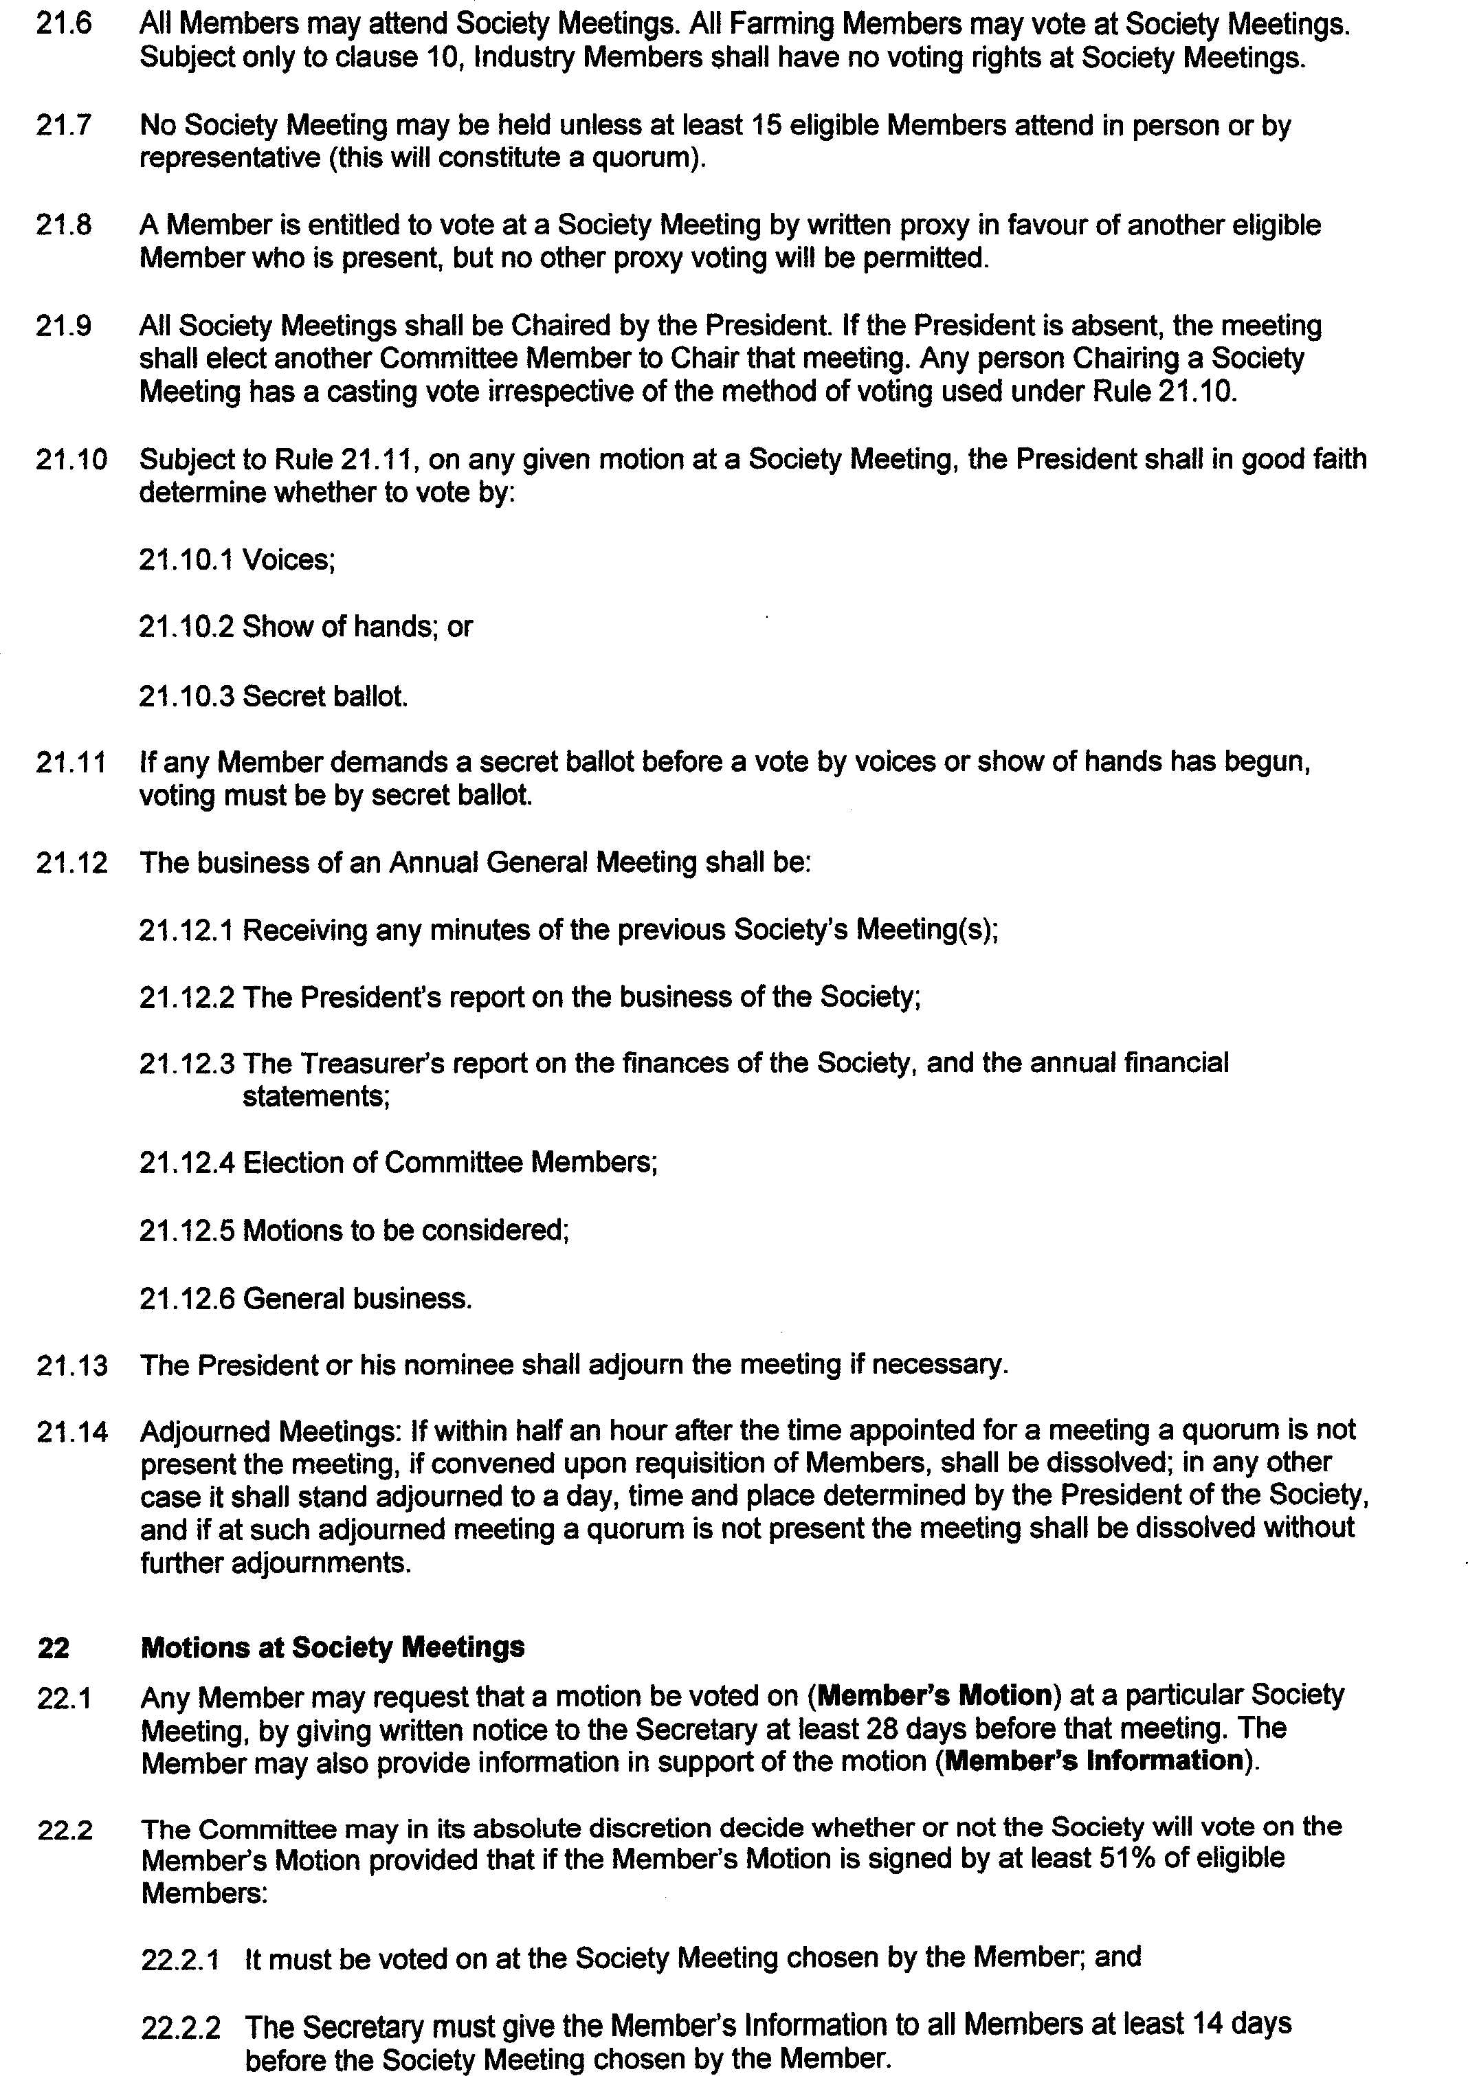

  - If the Secretary fails or is otherwise unable to discharge his obligation under Rule 22.2.2, the Member has the right to raise the motion at the following Society Meeting.

  - The Committee may also decide to put forward motions for the Society to vote on which shall be suitably notified {Committee Motions).

FINANCIAL

- Use of Money and Other Assets
  - The Society may only Use Money and Other Assets if:

    - It is for a purpose of the Society;

    - It is not for the sole personal or individual benefit of any Member; and

    - That use has been approved by either the Committee or by the Society Members.

  - Any transactions between the Society and any Member, any Committee Member and any associated persons shall be at arms' length and in accordance with prevailing commercial terms on which the Society would deal with third parties not associated with the Society, and any payments made in respect of such transactions shall be limited to:

    - A fair and reasonable reward for services performed;

    - Reimbursement of expenses properly incurred;

    - Usual professional, business or trade charges; and

    - Interest at no more than current commercial rates.

- Joining Fees, Subscriptions and Levies
  - The joining fee, annual subscription fee and any further fees payable for different classes of membership for the following calendar year shall be set by the Committee and notified to the Members at the Annual General Meeting.

  - If any Member does not pay a subscription or levy by the date set by the Committee or the Society, the Secretary will give written notice that, unless the arrears are paid by a nominated date (Payment Date), the Membership will be terminated.

  - The Member shall (without being released from the obligation of payment of any sums due to the Society) have no Membership rights and shall not be entitled to participate in any Society activity where full payment is not received by the Secretary on or before the Payment Date.

- Financial Year
  - The financial year of the Society begins on 1 April of every year and ends on 31 March of the next year.

- Assurance on the Financial Statements
  - The Society shall appoint an accountant to, at the discretion of the Committee (subject to any relevant legislation), either review or formally audit the annual financial statements of the Society (Reviewer).

  - The Reviewer shall conduct an annual examination with the objective of providing a report that nothing has come to the Reviewer's attention to cause the Reviewer to believe that the financial statements are not presented in accordance with the Society's accounting policies.

  - The Reviewer must be a suitably qualified person, preferably a member of Chartered Accountants Australia and New Zealand, and must not be a member of the Committee, or an employee of the Society.

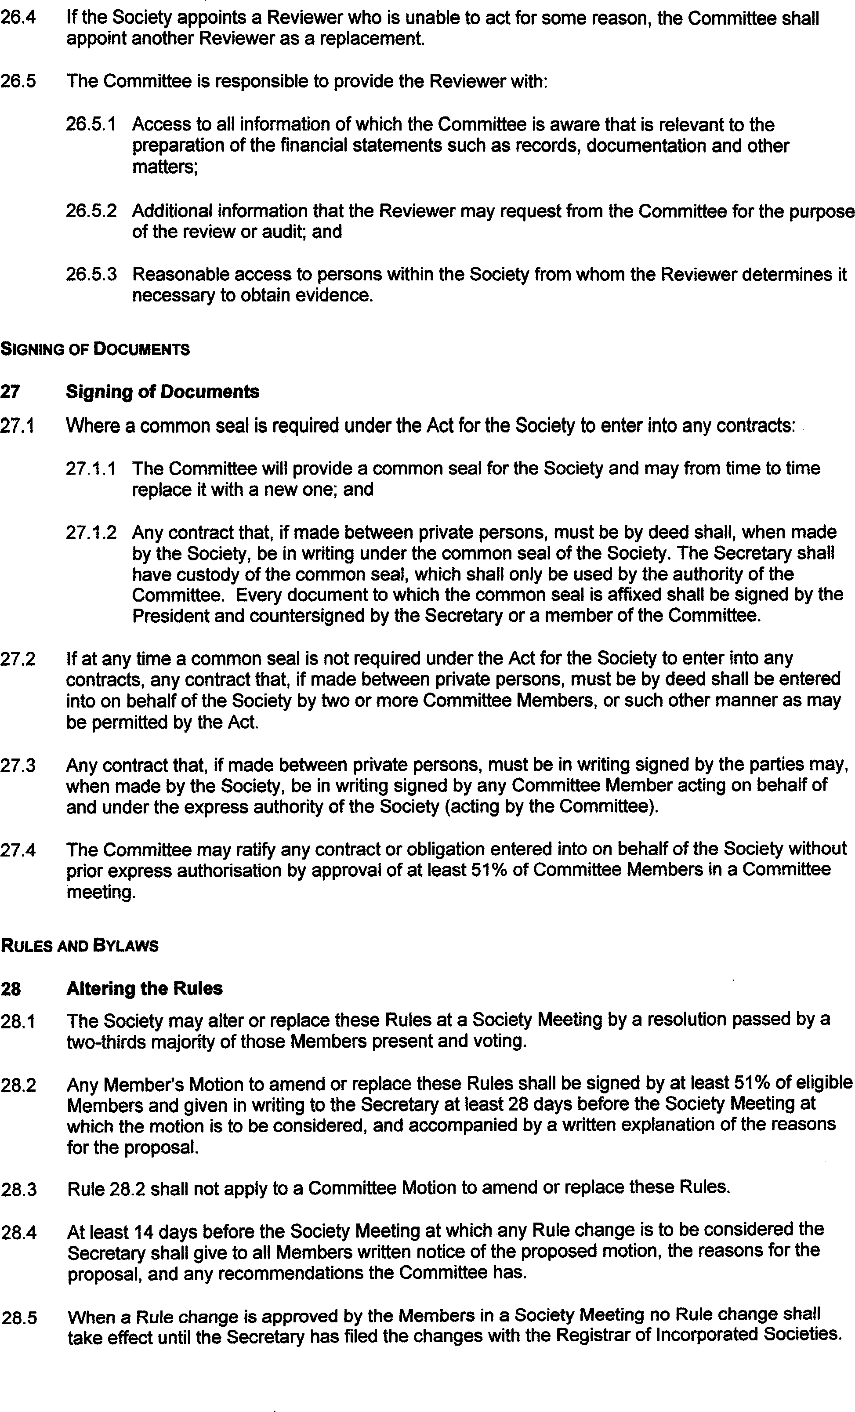

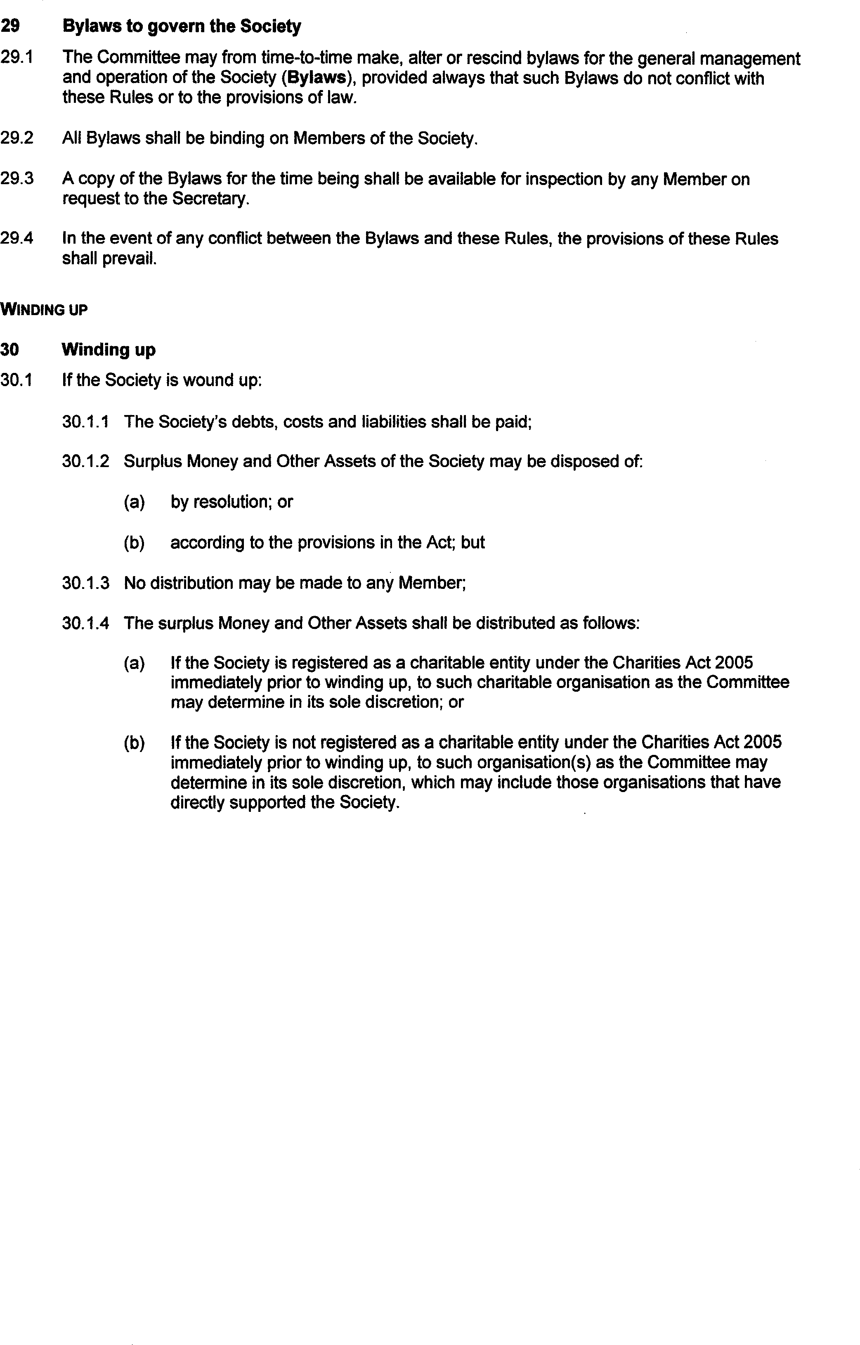

SCHEDULE

Initial Committee Members (Rule 6.4)

The initial Committee Members will be:
Committee Member | Deemed elector/appointee
b&.I E,vioe_ | twee NU1r Je-D C:,
1-1& I IVICN' 0j | llP f1E--P-. Iv A-1,t-t...f fY1{?,,..s'7
J/>QVJ f-1 Ho6/t:1'1
<Zci f1AC.iE-17-1 | etf:EV"1or 1-?21Z17PnV«.f CjlJoujJ.
Pl"rN Srf,tr-.1b
J/'rrVJB l-o.Jr€LLO
"'J:>ltYIZ) r/HC-1/rtrv/ | ,t/,11-w S tt.L . :
l>ttN b-1
/,,{/rM!S fl f!,,f/ffh? /l1;i!L/N
.!eov /IM.f/11..l
Jl'r:M Fr>aP"!" | lv/hPl{1?..A, t;1<(?1Jq 6Mtl/1 q. ,,,  1
I< €?IS, Ee..c A fflf l)f;
-gb-1 el-lrlr.c?V
MAN'1C oJf
6  ,J:/NDIZEW /ltS | ),,ol-f w/11Ai.1 4

.

I.a

